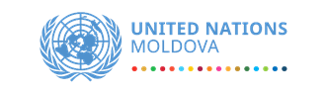
Coronavirus Disease – COVID 19
Situation Report No. 1 (20 March 2020)

This report is produced by UN Moldova in collaboration with Government and development/humanitarian partners. It covers the period from 17 – 20 March 2020. The next report will be issued on or around 23 March 2020.
Highlights – data as reported by national authorities*
- Another 17 cases were confirmed today, bringing the total number of confirmed cases to 66.
- Out of the total number of confirmed cases, 31 are imported cases, and 35 are local transmission cases. This is the first time when the number of local transmission cases exceeds the number of imported cases. The imported cases come from Italy, UK, France, Czech Republic, Switzerland, Ukraine and Russia. Local transmission has been reported for Chisinau, Soroca, Hincesti, Singerei and Stefan Voda.
- The largest number of confirmed cases was recorded in Chisinau (27), followed by Hancesti (15).
- Judging by the number of confirmed cases, the 50-59 age group has been the most affected, with 15 cases being reported in this group. However, the 20-29 and 30-39 age groups are not far behind with 12 cases each. Eleven (11) cases were reported in the 60-69 age group.
- The distribution of cases by sex shows that more women have been infected than men (37 vs. 29).
- Most cases continue to be treated at the Toma Ciorba Hospital.
- Seven (7) patients were in serious condition as of this morning.
- The total number of suspected cases stands at 83. No new recoveries or deaths have been reported as of the time of this report.
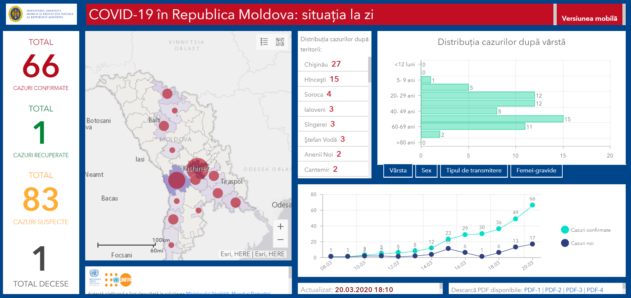

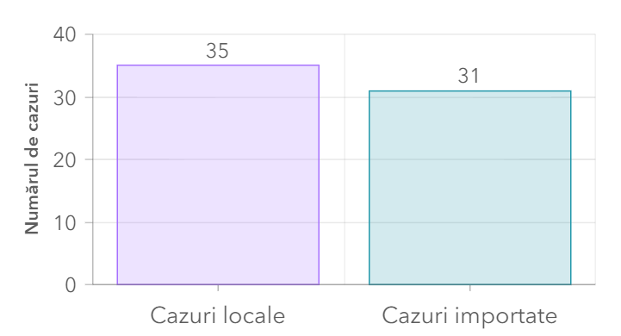
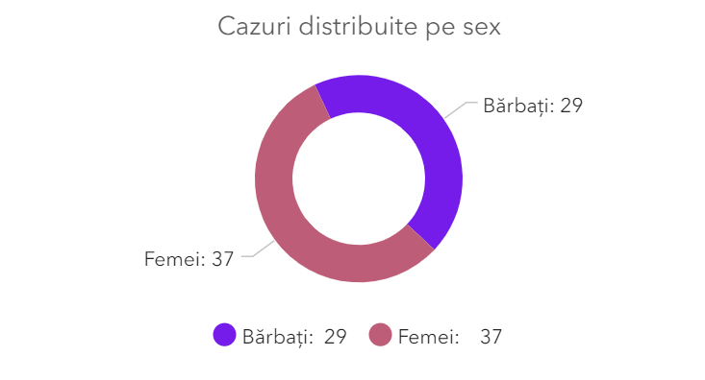

Overview of Key Decisions & Announcements
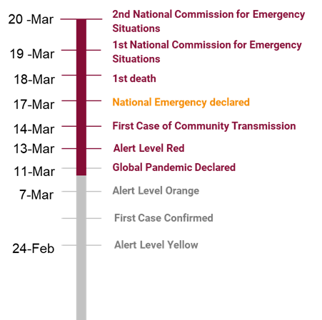

- On March 17, Parliament declared a state of emergency for 60 days, until May 15, 2020.
- A meeting was held on 18 March with MoH, Government, WHO, UNICEF, and UNDP to understand and to make recommendations for what these restrictions mean for Mayors and Local Authorities. This guidance has been shared by government
- The below outlines current restrictions and suspensions. However, clear directives have yet to be issued to compliment the Parliamentary decision.
- A meeting with the MoH, National Procurement and UN was conducted today morning to decide on a common approach to contact local vendors for the procurement of PPEs and equipment.
- Development Partners supporting COVID-19 response are invited to share information about their bilateral support with the Resident Coordinators Office in order to map all supports and avoid duplication of efforts. Focal person in RCO: laura.fiorotto@un.org and christine.petre@one.un.org
- WHO Partnership Platform https://covid-19-response.org/ has been launched. All partners are invited to participate. For more information send an email laura.fiorotto@un.org
- UN Moldova is committed to support the Government to address all the needs and are considering setting up a basket fund or multi-purpose trust fund. Partners interested in channelling support through the UN system are invited to contact Laura Fiorotto, Head of RCO, laura.fiorotto@un.org for more information.
- RCO/WHO is continuing monitoring the progress of the needs with the MoH. Agencies interested in receiving the latest need assessment can send an email to Laura Fiorotto.
- RC requested the creation of COVID-19 Groups (economic and social impact, agriculture, education) in order to assess needs in the medium and long term and prepare to support.
- World Bank, European Investment Bank, the International Monetary Fund, and the European Bank for Reconstruction and Development are all having active discussions with their counterparts on potential support packages / measures

Risks Identified for Vulnerable Groups
- A number of serious issues related to the Moldovan diaspora in the context of the Covid-19 emergency have been identified. The uniquely high ratio of the Moldovan citizens residing abroad has led IOM to identify a number of concerns including:
  - With the restriction on movements in EU Member States, there has been a growing sense of desperation among the quarter of a million Moldovans living in Covid-19 high-risk areas (e.g. Italy and Spain)
  - IOM estimation is that one in five of the 300K short term migrants work in precarious situations and would quickly become destitute as places of work are shuttered
  - Reports have reached us about irregular over-land travel to Moldova taking place which is already putting strain of the Moldovan Border Police and making it increasingly complicated to plan for contingencies
  - MFA has reached out to IOM regarding support for repatriation of Moldovan nationals stranded due to travel restriction, either from places of work or vacations; MD very limited funds to undertake such large-scale repatriations
- The Republican Drug Dispensary is facing multiple issues regarding the limited stocks of Methadone and the high number of patients attending the medical facility on a daily basis to receive single dosages. It is estimated that 100% coverage of patients could be achieved only by the end of April.
- Need to ensure access of ~800 HIV patients, including pregnant positive HIV women on the right bank to ARV drugs out of about 7000 of total in treatment on the whole territory of Moldova.
- 4 ARV drug positions out of the total regimens are of risk of stock out by the end of April 2020.

Economic impacts:
- The agricultural sector, especially plant production, may be affected by the Covid-19 outbreak as the declared state of emergency implies strict limitations on inputs supply for agriculture works and commuting of people while fieldwork should have commenced.
- Two of the country’s sixteen banks (Moldova Agroindbank and Moldindconbank) declared that they will delay payments on loans and credits by 2-3 months in support to reduction of Covid-19 impact on both, individuals and businesses.
- Increase of food prices, in particular for basic products, caused by high levels of demand. The import of some food products is also limited by state of emergency restrictions.

Preparedness & Response of UN System in Moldova
The UN Country Team prepared a Country Preparedness and Response Plan on 28 February, which included ensuring the business continuity of the UN office in Moldova, in support of the following areas of response:

Assessment and Data
- Assessment has been refined and put into the 8 Pillar format of the Country Preparedness and Response Plan, which is aligned to the global WHO Plan.
- Additional assessments will be required from other agencies for non-medical interventions in line with the UN Country Team management arrangements and Theme Groups and Task Teams.
- UNDP is preparing a proposal to undertake social and economic assessment to support short, medium and long term recovery. This will be discussed as part of the UNCT/UNDP led social and economic impact task force.
- UNDP is exploring with Orange the use of big data to understand the impact of restrictions on population movements and density, as well as potentially providing additional support to the elderly, if possible.
- UNFPA has launched a new real time monitoring dashboard about COVID cases in Moldova, disaggregated by age, gender, rayon, way of transmission, pregnancy. In just 2 hours after the launch the platform hit a number of 35,000 viewers and by 15.30 PM – 53.650 visitors. The link to the platform is available on the MoH web-site, UNFPA, UN Moldova web-sites and social media platforms. It was picked up by all media and will be further in social media for massive reach. Any embassies, agencies and institutions who wish to post this link on their websites please feel free to do so.

Migration
- IOM is developing a series of responses in the following areas:
  - Intelligence gathering and monitoring of mobility and movements though IOM’s displacement tracking mechanism and analytics from big-data;
  - Supporting repatriation through IOM transportation facilities, emergency livelihood support and camp coordination to support the most vulnerable cases of stranded migrants;
  - Communication and messaging regarding the risks of traveling, targeting diaspora communities through consulates, diaspora organizations and social media;
  - Improving preparedness at Border Crossing Points regarding screening, quarantine facilities and care facilities.
- IOM is evaluating the needs for the migrant population and has developed a concept note with a budget for support that would be needed in the short term.
- IOM undertook on Friday (20 March) a scoping mission at the border crossing at Giurgiulesti to assess the inflows and operations over the main entry point for Moldovans returning from EU countries. IOM was able to see the procedures for screening and separating suspected cases of COVID-19, how countries visited/resided was documented and the need for protective equipment and materials, especially in the event of surge of border crossings. IOM congratulated the personnel of the Border Police for their diligence and sacrifices under the current conditions, noting the first case of infection among their staff.

Education
- The first virtual meeting of the UN Education Task Force, hosted by UNICEF (in relation to school closure and distance learning) took place on 19 March;
- A letter was prepared for sharing with MECR informing of the support UN Agencies can provide for the organization of continuity of learning and child care and protection during school closure.
- UNICEF shared with UN Education Task Force the UNICEF Education – COVID19 Response Concept Paper
- Ministry of Education, Culture and Research (MECR) developed and approved the Methodology for the continuation of distance educational process during quarantine with consolidated input from UN agencies;
- Dialogue between the UN and MECR raised the issue of school meal provision to the most vulnerable students during school closure. Issue will be taken up with higher level decision makers, with a response expected in the next few days;
- UNICEF is also looking at possibilities with MECR to identify most efficient mechanisms for provision of school meals to the most vulnerable children during school closure. This might include changing the budget line for school meals to have direct cash transfers to most vulnerable families or to transfer these funds to LPAs for redistribution to the most vulnerable households with children.

Gender
- UN Women is continuing to engage with Partners – particularly civil society on contact tracing and needs assessment. The tools and guidance for contact tracing will be shared with the CSOs as soon as received/agreed with MOH.
- Online consultation with member of CSAG (UN Women Civil Society Advisory Group) and Secretariat of Gender Equality Platform.
- The United Nations Gender Theme Group meeting was convened on 18 March and agreed on the following critical areas:
  - GBV/VAW: This has been identified as a critical issue during the pandemic situation, that will need joint approach. A consultative meeting with the Coalition life free of violence took on place 19 March discussing communication aspects, services availability, including shelters and day care facilities, on-line counselling, GBV within home and involvement of police, social assistance and medical services at local level etc As a result, it was agreed that a rapid needs assessment will be conducted immediately for shelters and NGOs providing services to victims of domestic violence to further inform targeted intervention to maintain these services. In addition, NGOs are developing advocacy plan to engage the government not to suspend activities of the shelters and continue to provide support to women. i.e. sanitizers, protection masks and food supplies).Social-Economic Impact Assessment: Agencies will be joining efforts together with RCO, in undertaking the Socio-economic assessment, including on the gendered impact of the COVID-19;
  - Communication and targeted messaging to be developed and targeted for various vulnerable groups;
  - Gender mainstreaming: participation in different meetings and platforms to make use of the GTG membership and gender expertise to ensure that gender is mainstreamed in all interventions.
  - UNFPA developed and promoted technical guide on COVID-19: A gender lens

Health
- The World Bank is preparing a project seeking to provide immediate support to respond to the COVID-19 outbreak, with a focus on limiting community transmission, and building capabilities to handle severe case, on the one hand, and on providing adequate social assistance to the most vulnerable population affected by the crisis, on the other hand. The project will seek to stem community transmission through containment strategies, a focus on infection prevention and control (IPC), as well as bolstering intensive care units (ICUs) to accommodate surge for patients with severe symptoms and the onset of acute respiratory infections. Eligible expenditures will include infrastructure support and training, to build national capacity in intensive care case management for both children and adults. Depending on the Government’s approval, the project will also include social and financial support to households. In the event of an outbreak not materializing, these investments can be repurposed to build flexible capacity for future epidemics, bearing in mind that a resurgence of the outbreak is anticipated in the near future. While the project is expected to be approved by the end of March, 2020, it will allow for retroactive financing of up to 40 percent of its cost for expenditures undertaken before its approval. The size of the project is being agreed upon with the authorities.
- WHO concluded a two-day training of MoH staff for the net round of hospital assessments. This was done online by an external consultant using the newly established UN Operations Room;
- The Republican Drug Dispensary is facing multiple issues regarding the limited stocks of Methadone and the high number of patients attending the medical facility on a daily basis to receive single dosages. UNODC has provided guidance on limiting the number of patients and prevention/protection measures for staff. This issue will be discussed in the joint group on ARV, TB and Methadone drugs group organized by PAS and UNAIDS.
- The National HIV program with the support of UNAIDS, WHO and community organizations :
  - UNAIDS, UNODC, WHO National HIV/TB Programs specialists, NGOs developed BCP plan to ensure the vital continuity services to PLWH and TB patients;
  - Jointly with the National HIV programme, UNAIDS supported the development of an SOP for the alternative delivery of ARV drugs to 800 patients all over the country with the support of NGOs active in HIV field. It is now with the Ministry of Health, Labor and Social protection for approval;
  - WHO bureau will train the social workers from NGOs on the protective measures to be taken when delivering the drugs;
  - UNAIDS recommended all the NGOs to provide asap the needs for protective measures: in terms of masks, disinfection and gloves
  - UNAIDS and NGO “Positive Initiative” supported 4 PLWH illegal migrants in Italy and Russian Federation to get their ARV drugs; for 4 PLWH one in Germany, Portugal, Turkey, Switzerland solutions to support those through host countries HIV NGOs are looked for with the support of UNAIDS HQ.
  - The National HIV programme will provide by 23th of March the needs for 4 ARV drug positions, including for the Tranistristrian region for 6 months to UCIMP (Global Fund) UNICEF, UNDP to start an emergency procurement.
- Covid-19 in prisons is of serious concern;
- UNICEF, WHO, UNDP provided advice to the National Commission on Emergency in Public Health on the development of a Guideline/Instruction for LPAs and Mayors on their responsibilities and actions during the national emergency declaration related to COVID-19 pandemic. The instruction provides support to Mayors on their actions in case of quarantine, how to support at risk groups of population (elderly +60, with diabetes, cardio-vascular diseases, respiratory chronic diseases, HIV/AIDS, TB), how to monitor people that returned from countries with local transmission of COVID-19 in the last two weeks, ensure social distancing in public institutions – police, pharmacies, post office, grocery stores. Instruction will be shared with all 1st level LPAs.
- UNFPA developed and promoted guidance on COVID-19: pregnancy and breastfeeding.
- UNICEF shared the UNICEF Supply Division list of equipment designated to COVID19 response with UN agencies and MHLSP in Feb’19, and related request submitted this week. Given the limited stock as well as the large current demand also by other countries related prioritization exercise is underway by UNICEF Supply Division in Copenhagen.

Communications
- Instructions for mayors developed by UNICEF, WHO and RCO on how to communicate with persons having the highest risk of being infected with COVID- 19 (elder persons, persons with disabilities and persons with chronic diseases) was developed and disseminate to all mayors, members of local councils and presidents of raions (1,200 total) together with some other useful informational material.
- The main Internet providers (including internet TV) have been reached by the MoHLSP to serve as information channels being requested to put banners/text messages on the screen of TV/laptop as pop-up every several hours or based on another algorithm. This initiative in expected to launch in a few days;
- The launch of the UNFPA led COVID-19 Monitoring Dashboard took place place likely on 20th March
- UNICEF provided support for government’s social media campaign #StaiAcasa (Stay Home), with 4 video testimonials: more than 200,000 people reached via UNICEF platforms. Other two video are under preparation;
- UNICEF distributed through various media advise for parents on how to communicate with their children about the COVID-19 outbreak;
- UNICEF distributed a compilation of learning from home platform to support parents, teachers and students through 15 mass-media channels.
- UNICEF is looking at innovative solutions in communications about COVID-19 through supporting a 3 days hackaton;
- UNICEF reached out to the media on the left bank of Nistru with communication materials on COVID-19;
- UNFPA used 44 Youth Centers social media accounts and platforms to disseminate message related to COVID prevention and the #StayHome campaign challenge launched by the MoHSP was initiated among the Network of Youth Centers. The Cimislia Youth Centre and Straseni Youth Centre picked up the challenge and posted video calls and photo collages made by young volunteers with the call to #StayHome. UNFPA continues to engage influencers to join the campaign and amplify the messages.
- UNFPA youth life skills programme was used for disseminating all communication materials produced on CIVD-19 to schools and VET institutions.
- A series of materials containing messages aimed to support women in the period of COVID-19 outbreak is being developed. The main objective of these materials is to help women to stay safe and receive all the necessary support from their communities.
- Public statement on for messaging for pregnant women relating to COVID-19 published via UN social media accounts
- Messaging on COVID-19 disseminated through multiple UN agency platforms targeting groups that include Youth Centres and schools across the country, hometown associations, human rights platforms, groups from Transnistria region, and platforms for EU confidence building.
- OHCHR shared information related to COVID-19 with all networks available to OHCHR including Roma Community Mediators, paralegals, extensive network of CSOs including NGOs working with persons with disabilities and including CSOs from the TN region. OHCHR facilitated the translation of communication material into Romani, Ukrainian and Gagauz. UNAIDS shared the information with the NGOs active in HIV/TB field through Key affected populations platform, including Transnsitrian region.
- Provided guidance to the Government communication group/UNCG on how to ensure communication is accessible to the most vulnerable parts of society.
- UNDP continues to use all social media channels and programme platforms to disseminate COVID-19 information with focus on the most vulnerable.

Human Rights
- OHCHR continues to monitor legislative changes, decisions issued by the Commission on Exceptional Situations and the implementation of the aforementioned to assess their human rights compliance.

Gaps/Needs Identified
- Additional assessments for non-medical interventions;
- Coordination of member states requests vis a vis contribution to the overall needs assessments

Challenges
- International procurement remains challenging in the current global crisis;
- Coordination of actions for the organization of continuity of learning during school closure;

Content Contact
Christine Petre, Special Advisor to the UN Resident Coordinator
christine.petre@un.org

Media Contact
Cristina David, Communications and Advocacy, Office of the Resident Coordinator
cristina.david@un.org

Facebook: https://www.facebook.com/ONUMoldova/ * Twitter: @UNMoldova * https://moldova.un.org/

